**Experiment No. 8**

1. **Aim/Overview of the practical:**

Create and maintain file storage using Blob.

1. **Code for practical:**

* Open Azure portal and go to ***resources>storage>storage account>create***.

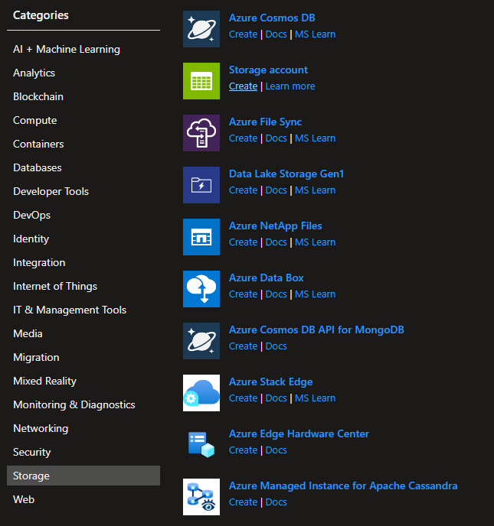

* Enter name of resource and select plan to standard.
* Click on create button.
* Your resource will be deployed in few moments.

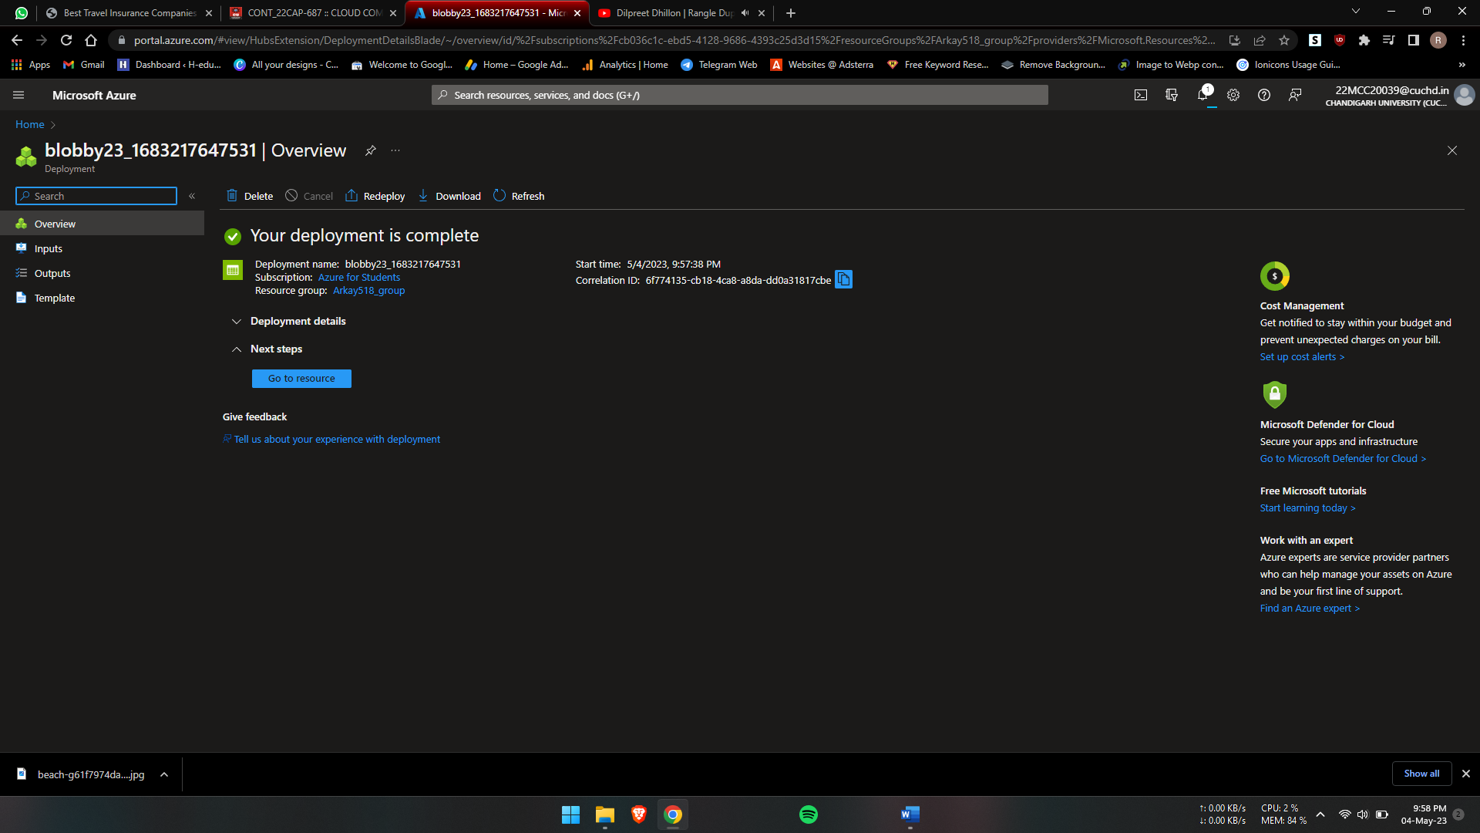

* Click on upload and upload and file or directory.

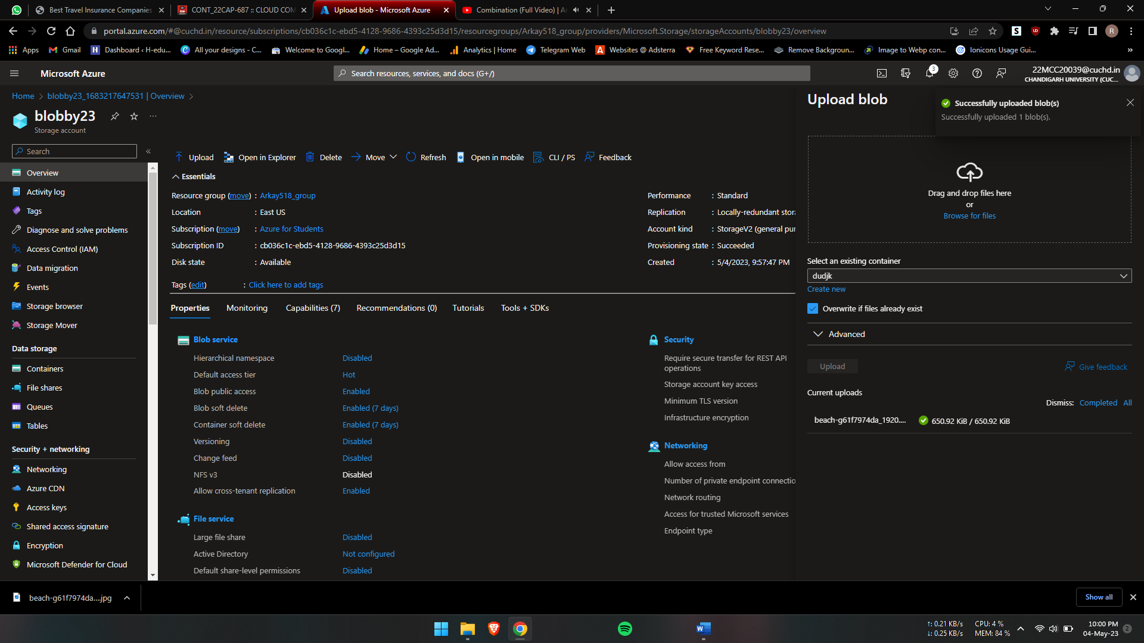

**************************************** **THE END** ***********************************************